**Part A Results**

Plotted using Microsoft Excel

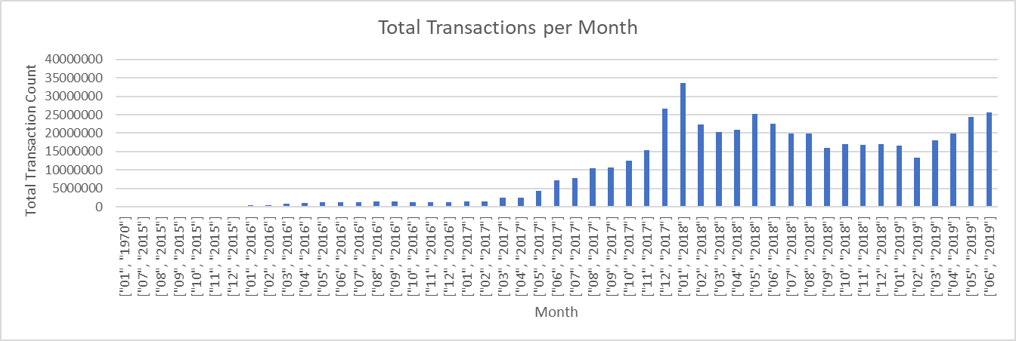**A1**

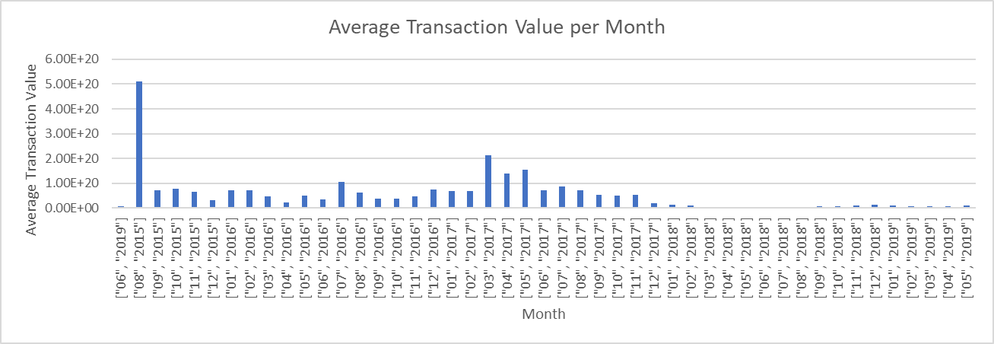**A2**